**Assignment 7.6**

**Write a map reduce program save the output of the word count program in XML format. You need to write a custom writable to save the output in XML format.**

**DRIVER**

**Set output format class as XMLOutputFormat.class**

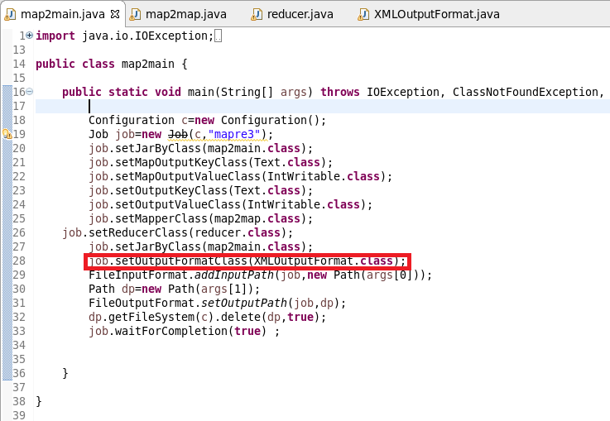

**MAPPER**

**Sending company name as Key and a count of 1 as value after filtering “NA”**

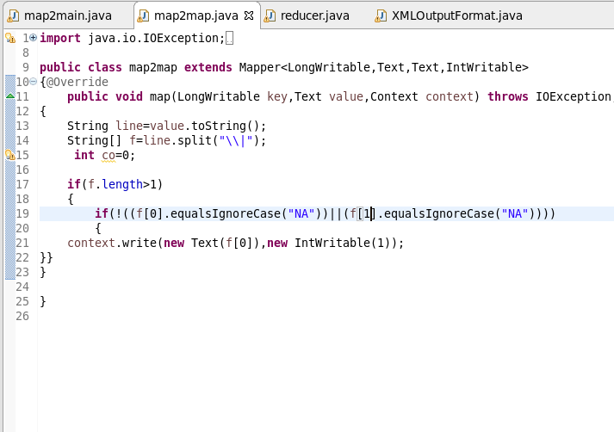

REDUCER

MADE THE TOTAL COUNT

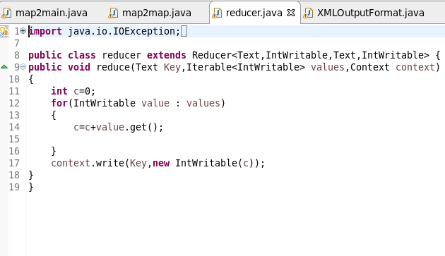

XMLOUTPUTFORMATCLASS

STEP1: Extending File output format and Override Recordwriter method for writing the output from record writerset extension type as XML

STEP2: Extending recordwriter class and override write method to write the key and value as XML like format and then used closed method to close.

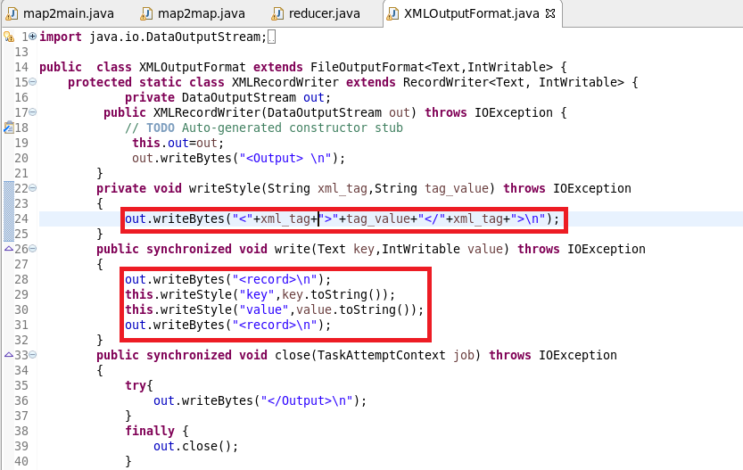

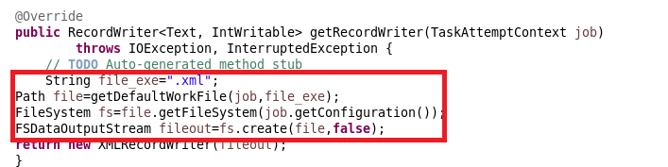

RUNNING JAR:

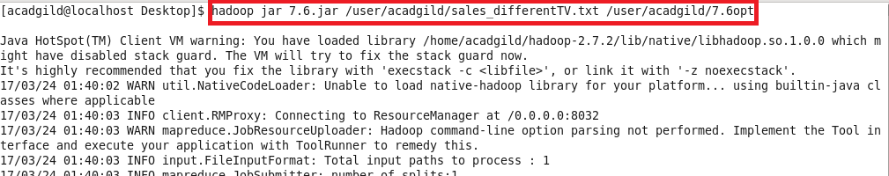

OUTPUT:

